Acts 14

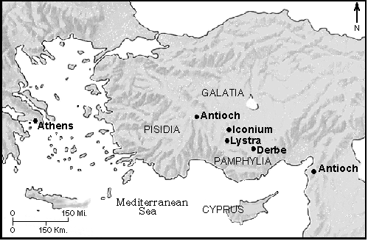

1 Iconium is about 90 miles east and southeast of Antioch (150 miles south of Ankara the present capital of Turkey) and was considered the capital of Galatia. It was on the Via Sebaste that linked it to Ephesus. It had plenty of water and an agricultural plateau. It enjoyed a friendly relationship with Rome. It had a Jewish community with a synagogue.

Paul and Barnabas – in 13:2 it was Barnabas and Paul, but since the conversion of the Roman proconsul the order switched. In Greek writing, the prominent person is mentioned first. This says a great deal about Barnabas ability to humbly take second place.

“as usual” Even though the last chapter had them telling the Jews that they were going to the Gentiles (13:46), we must take that as to the Gentile community of Antioch. “spoke so effectively” Effectiveness is of the Holy Spirit. (Acts 17:2) Someone asked if I felt anything because of the prayer team Sunday. That isn’t what I look for. I look for people being affected by the Word to know that the preaching was effectively presented in the power of the Holy Spirit. That is what we need in our individual witness as well.

2 “refused to believe” It is a matter of the will. If the truth is presented and supporting Scripture is given, the only thing that keeps them from converting is a refusal to believe. This is the same response they received in Antioch, but it was worth it as many believed. Archeology shows evidence of a deeply rooted Christian community. (Acts 17:5) Persecution is to be expected when you share the truth.

3-4 “miraculous signs and wonders” These were probably healings and exorcisms. The city was being divided and God’s grace was giving ample proof that their message was from God. (Galatians 3:5)
Luke labels Paul and Barnabas as apostles in verse 4. The meaning is official representative since they were sent out by the church at the Holy Spirit’s instruction, but strictly speaking it meant a witness of the resurrection. Divided – John 7:43

5-7 God revealed the plot of the enemy and spared them from physical attack this time. The church of Iconium was established and now the Gospel was going on to the Lycaonian. Psalm 83:5; Matthew 10:23

8 –10 Lystra was a Roman colony founded in 26 BC. It was about twenty miles south of Iconium but a days walk from the Via Sebaste. This was an amazing miracle. To jump and walk there would have to be a miraculous addition of bone mass and muscle tissue as well as nerves linking up to enable him to move.
“saw he had the faith” an interesting expression. This crippled man was receiving the Word and so Paul knew he could receive healing as well. Acts 3:6-8

11 Zeus and Hermes – Ovid tells a legend of Zeus and Hermes coming to visit this area finding no hospitality until late in the day an old couple invites them in for the night. The gods lead them up on to a hill while the inhospitable inhabitants below are drowned in a flood. There home is turned into a marble temple. No wonder the residents were so eager to honor Paul and Barnabas after seeing the miracle. They thought the visitation was happening again. Acts 28:6

12 Hermes was the one who spoke for the gods, and so Paul was given that title.
13 Though the temple hasn’t been discovered, there are numerous inscriptions to Zeus and Hermes in the city ruins.

14-15 The last thing they wanted was for the people to worship them. This was probably the first time they had encountered this kind of a reaction to a miraculous healing.
Jews saw idols as worthless things, like a broken dish. Paul’s words must have stung those who wholeheartedly believed in Zeus and Hermes. He contrasted them with the living Creator. The implication is that the gods are dead. Paul’s statement had to be offensive to the pagan worshippers, but it also began a message to them that they could relate to. Since they are all Roman, Paul does not use Scripture they are unfamiliar with but points to the one true Creator and the emptiness of idolatry. Acts 10:26

16-17 Though God constantly intervened in Jewish history, He left the rest of the world with the testimony of creation and daily benevolence. Romans 1:20; Acts 17:27-30

18-20 From a god to a convicted felon, man is fickle. If he hears what he wants, he will elect you, if he doesn’t he will stone you. From Antioch – that’s 100 miles! John 15:18-19 Perhaps someone trading goods told them of Paul and Barnabas visit to the city. We don’t know why they didn’t stone Barnabas, perhaps it was because Paul was the speaker. Stoning is uniquely Jewish form of execution. The Jews from Antioch and Iconium must have been the stone throwers as the town of Lystra looked on in approval. The disciples must have gathered round to pray over him and God miraculously raised him… and they went back into the city! Until the opposition died down, they went on to Derbe. Apparently they did win disciples in Lystra in spite of the opposition, because they will return.

