Acts 15b 15:36-16:10

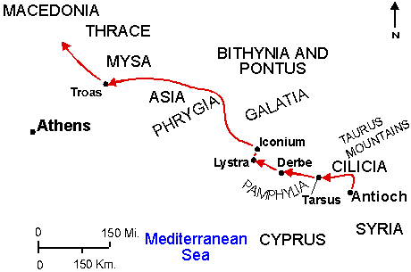

36 After ministering for some time in Antioch, Paul had a desire to go back and make sure the churches that they started were doing well. Those who lead others to Christ will have a burden to see they grow and are discipled.

37 –39 John Mark had gone with them with them on the first trip but left when they arrived in Asia Minor. 13:13 Paul didn’t think JM was reliable. Was the cost born by the church in Antioch? They couldn’t agree, so Barnabas took JM and went ahead without Paul. This is the last we hear about Barnabas.
The wording “sharp disagreement” paroxysmos is from a colorful Greek word. It was used twice in the Old Testament to describe the furious anger of God. This was a major blowup between two Godly men who could not agree. Paul will later be reconciled with John Mark. (Colossians 4:10; 2Timothy 4:11)

40-41 The result of the dispute is that they go in two different directions and end up ministering to twice as many places. The church sent Paul and Silas who was either still there or returned from Jerusalem. It is interesting that they didn’t mention the church sending Barnabas. Silas accompanied Paul overland visiting the churches others had established and ones Paul and Barnabas had founded. The route took them up through a narrow mountain pass called the Cilician Gates. How do we “strengthen the churches”?

16:1-2 Now they are back up in the region that Paul and Barnabas had ministered in. Lystra was the place Paul had been stoned. During that first visit to Lystra, three generations of the same family came to faith. (2 Timothy 1:5) Fruit had come out of that persecution. Timothy had grown so much in the faith in the short time Paul was away, that Paul invited him to join them. Paul would become Timothy’s mentor. The testimony of the brothers confirmed that Timothy was consistent in his faith. He will become Paul’s most fruitful disciple and will even be considered like a son. (Philippians 2:22)

3 Since his mother is a Jewess, he is considered a Jew, though they were not apparently living a devout Jewish life or he would have been circumcised. Paul circumcised him so as to not offend the Jews they were ministering among. It is an important lesson for us to see that though Paul fought ardently for the truth of salvation by grace through faith, he did not put a stumbling block in front of people if it could be avoided. Timothy didn’t have to be circumcised, but he was for the sake of the weaker Jewish brothers. (Romans 14:13; 1Corinthian 9:19-20)

4-5 They put to rest the fears that developed when the Pharisee converts came and told them they had to keep the Law. Silas presence helped to confirm that this was indeed from the Jerusalem council. Strengthened and growing – that is God’s vibrant plan for healthy churches.

6 They went through Asia but felt the Holy Spirit was restraining them from preaching the word. There are times when we are to be silent witness. This passage is seldom referred to because we usually have the problem of not speaking up when we should. This team was dependent on the Holy Spirit for direction of when and where to speak.

7-8 They had one desire, but the Holy Spirit had another. What do we do when we feel like doing one thing, but there is check in our spirit that it is not what we should do? Can we do more harm than good when we “witness” as we please?
(1Peter 1:1)

9 God doesn’t always give us direction ahead of time. He was forbidden to go North or South and he has gone as far west as he can go. Sometimes God doesn’t guide until we come to the end of our plans. That keeps us looking to Him for His leading. This was not a dream; it was a vision. Now they know what to do.

10 When you don’t know what to do or where to go, keep your eyes open for God’s answer. They assumed that this was it. How would they know if it wasn’t?
Notice that the text now changes to first person “we”. Luke must have joined them in Troas.

Some thoughts to consider: How can we become sensitive to the Lord’s direction? What if they disagreed? Why would God keep us from speaking in an area or arena of life?

